Abdul Haseeb

20F-1066 | BSE-7A

DevOps Project

Task-4

**Deploying web app report**

# **Cloning git repository**

Cloned a web application from my GitHub repository to use for deployment.

I have cloned this repository on my local machine using git.

### **Link:** <https://github.com/abdulhaseeb20/tic-tac-toe.git>

# Microsoft Azure Account Setup

Accessed Microsoft Azure website.

Provided personal details for new account creation.

Provided billing information.

Verified account creation.

# **Created Web App Resource**

On the home page, I clicked on ‘Create a Resource’ option.

Selected ‘Web App’ from the listed options.

Provided all necessary information.

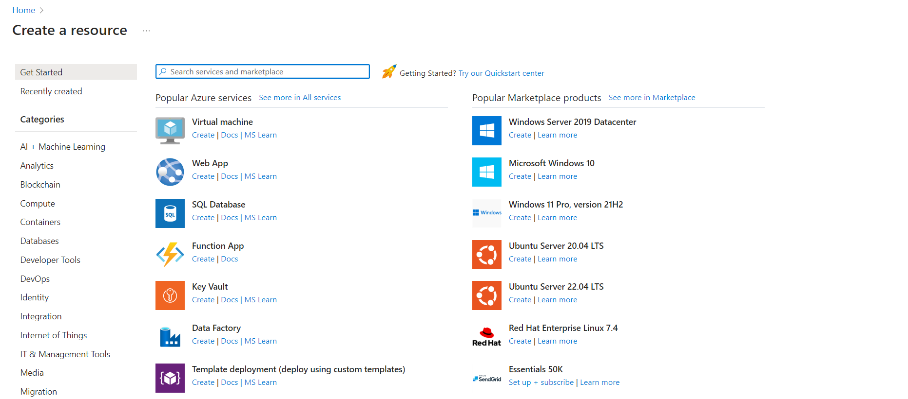

# **Configured Web Application**

Configure the web application by providing name of application.

Select an appropriate stack. I selected .NET stack.

Configure the subscription plan according to your needs. your needs.

Link GitHub repository and click on ‘Review and create’.

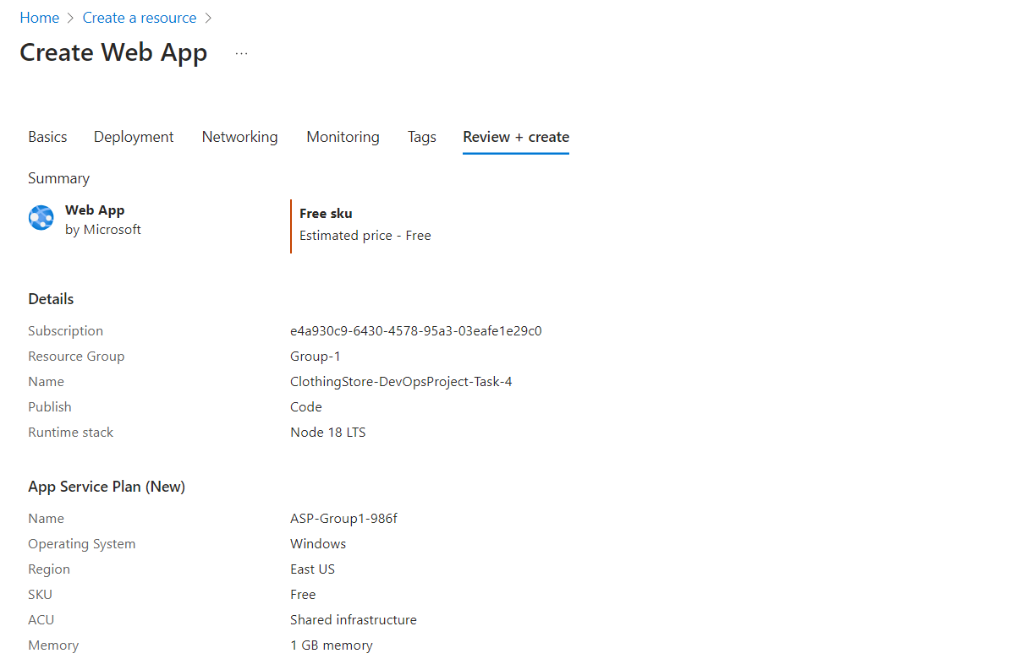

# **Deploy App**

After providing all details of app, finally click on deployment.

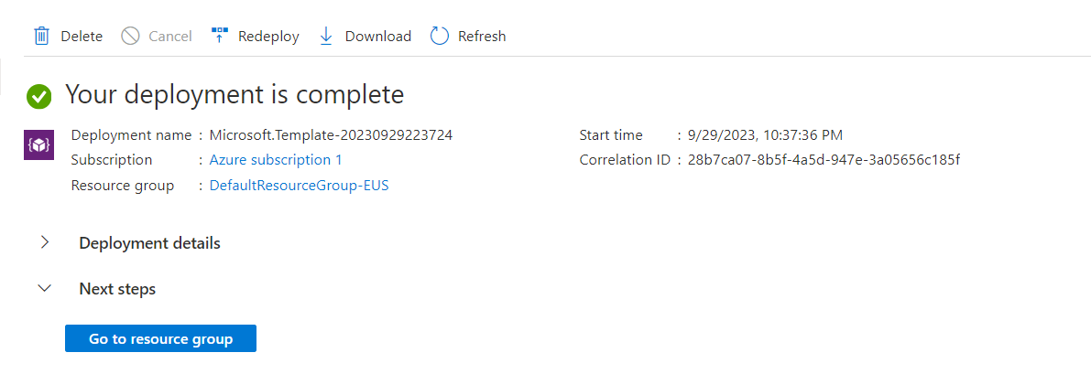

**VS Code Integration and Deployment**

# **VS Code Setup**

Install Azure services extension in VS Code IDE.

Enable the extension and login to azure account.

Open the app created in the resource of azure dashboard.

# **Deploying App directly from VS Code**

Deployed my app directly from VS Code.

Track on deployment can be monitored easily.

# 

Application can be accessed in the browser by the following URL:

<https://clothingstore-devopsproject-task-4.azurewebsites.net/>